Quick Start Guide
Pro Series

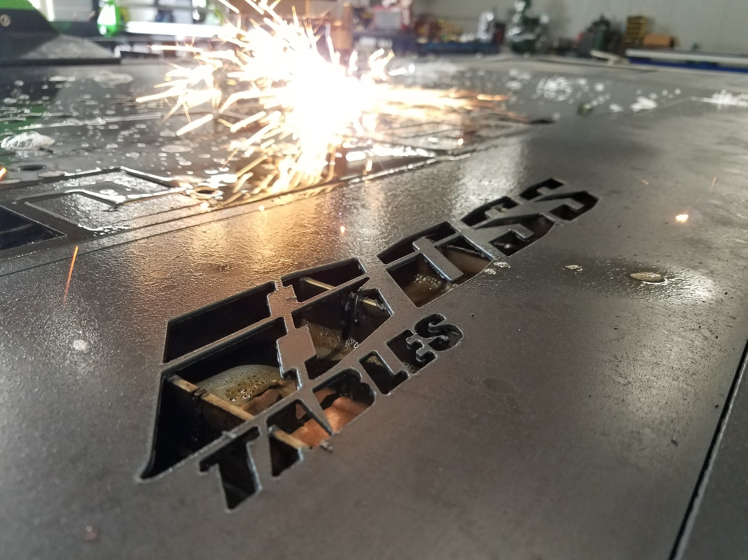

Contents
Getting Set UP 3
1- ANY DAMAGE 3
Hypertherm Info 10
Mechanized consumables 11
Non-continuous pilot arc Torch lock* Mode switch 11
Check your status screen to ensure that there are no fault codes to troubleshoot 13
Fault icons 13
1. Overcut 23
2. Lead in and Lead out 23
1. You have homed your machine but your image is located in a random location 31
Home sets 31
Zero sets 32
3. Shift Parts. 32
4. Zero Z Axis. 32

Getting Set UP
- ANY DAMAGE call immediately 563-380-1535
- Unstrap computer stand and remove from bed. 2 people may be needed to lift and place on ground.
- Place slats in bed, they are cut to length and can be placed into bed without a certain order. The slats are curved so that straight cuts will not fall directly onto the top of the slats.

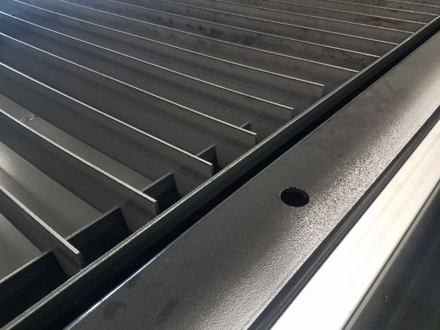
- When your slats need to be replaced the easiest way is to purchase 3” X 1/8 steel strap and cut to length.
- Remove the torch from wrapping and place on magnet mount. The machine will not come out of E-Stop without the torch in place on magnetic mount. The Torch has an ohmic Clip installed, you will need to connect the black covered wire to the clip. To let the machine find the height of the steel.
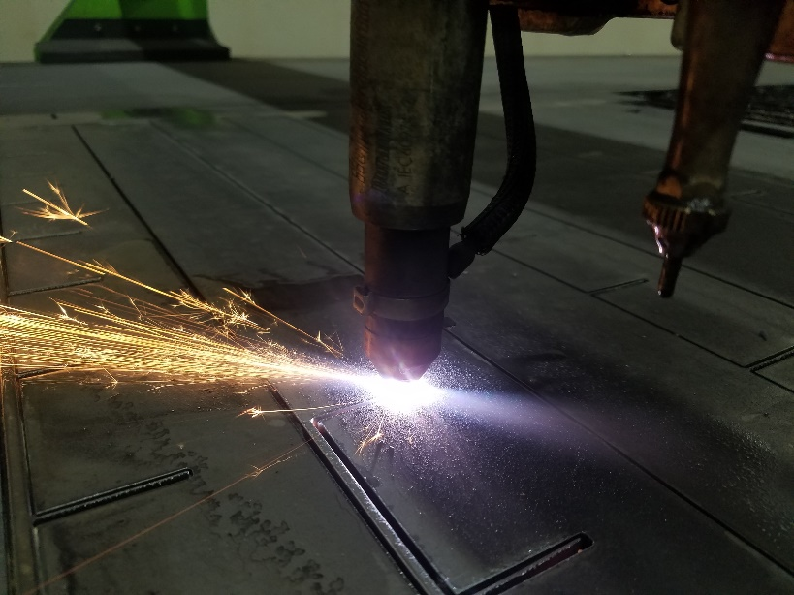

- There is a E Stop Switch located on the steel plate used for the magnetic breakaway, the switch has to be depressed to allow the machine to come out of E Stop. (You need to have the torch mounted to remove E-Stop.)
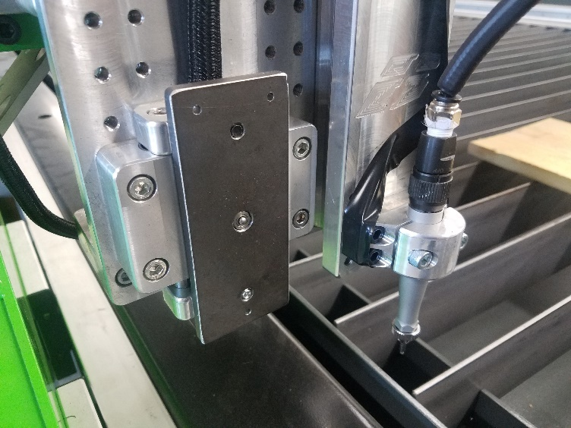

- Ensure that the E-Stop buttons are not pressed as the machine will not come out of E-Stop. There are 2 located on gantry and 1 on the computer stand.
- Level table. There are leveler feet located on the bottom of the legs. The table does not need to be perfectly level but the table will not drain properly if the drain is higher than the cutting area. The drain is located on the side of the controller. There is a black cover/ grate covering the “Drain”. You will not need to remove the cover for any reason unless parts or debris is interfering.

- Close the valve located on the bottom of the table. Very Important as you will dump cutting fluid on floor if valve is not closed.

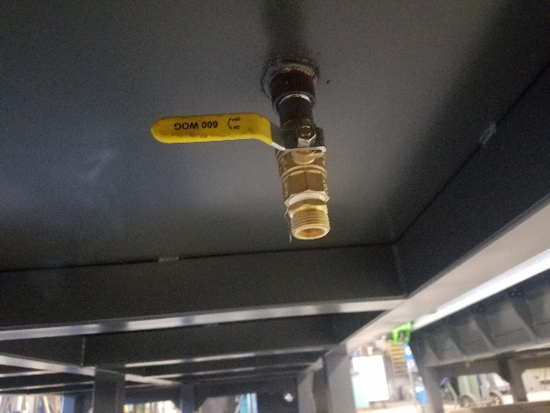

- Dump the BOSS Tables cutting fluid into the table anywhere in the cutting area. 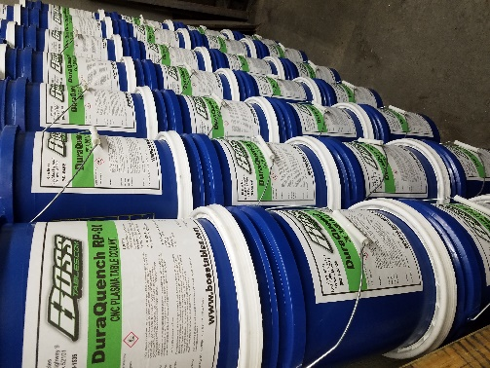
Then begin filling with water. Use any water available if it is clean. The 3/4 valve located on the control end of the table is the water/air valve(Left in picture). The valve needs to be open to allow air to escape and water to fill the lower tank. The table is full when the lower tank is full. Water level can by observed with a flashlight shining through the grate. The water level will rise in the lower tank and is full when the water level meets the floor of the cutting area. (the bottom of the grate) If over filled it will not hurt the machine and you can just let the extra water evaporate or utilize the table drain located underneath the table. This will take some time as the table holds approx. 300 gallons. 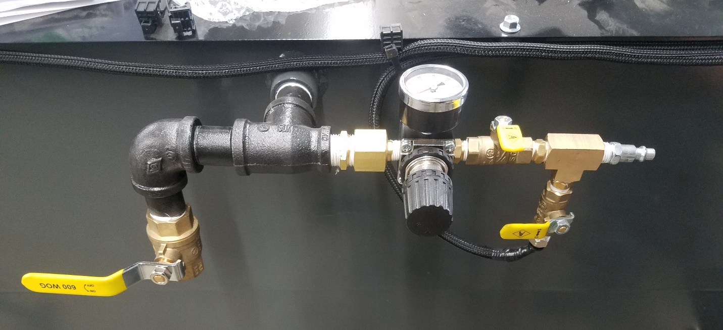
- Air pressure supplied to tank is applied from control end of the table. The smaller valve is used to supply air into the tank. The larger ¾ valve need to be closed to allow the air to push the water into the cutting area. If you table has a pneumatic scribe the small valve pointed down supplies air pressure to scribe. The air pressure will need to be supplied to hold the scribe up in the travel position.
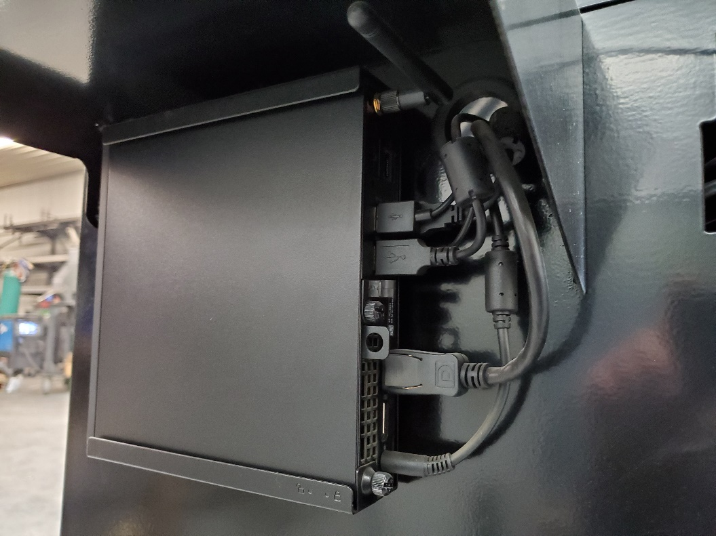
- Plug in computer. Computer is in a small box, the mount is on the right side of the computer stand. Slide the computer onto the mounting fixture and plug in the monitor, mouse, keyboard. The extra cord can be pushed into the hole that the wires are ran through.
- Mount monitor the mounting screws are located in the back of the monitor
- Place key board and mouse on stand and place extra cord in hole next to computer mount.
- The computer stand has a surge protector located in the control cabinet. But another level of protection at your breaker box is recommended.
- If customer is supplying their own torch the torch cable will need to be fixtured in the cable track. Open the cable track and lay in torch lead. Ensure the torch lead has proper clearance for z axis travel. The torch should be approximately fixtured 4 inches from the bottom of the z axis. The torch can be adjusted as needed to cut larger items such as 4 inch pipe ect.
- Ensure that the table is cleared off and all personnel is out of way.
- Press power button located the front of controller in cabinet. It’s a rocker Switch The light will illuminate when turned on. Turn off at the end of the day.

- Ensure that home screen is shown. From there you can explore the computer if wished. But the settings are not to be changed unless specified by BOSS Tables. Feel free in future to create folder and save DXF, job and other files on computer. But it is not advised to troll the internet for free DXF and or other personal needs. Think of it more as a controller than a computer.
- The power button on the computer will not turn on the motor drivers and motors. The motor driver/power button is in the computer stand on the controller.

- Once the interface is open you will notice lots of buttons that will be talked about later. 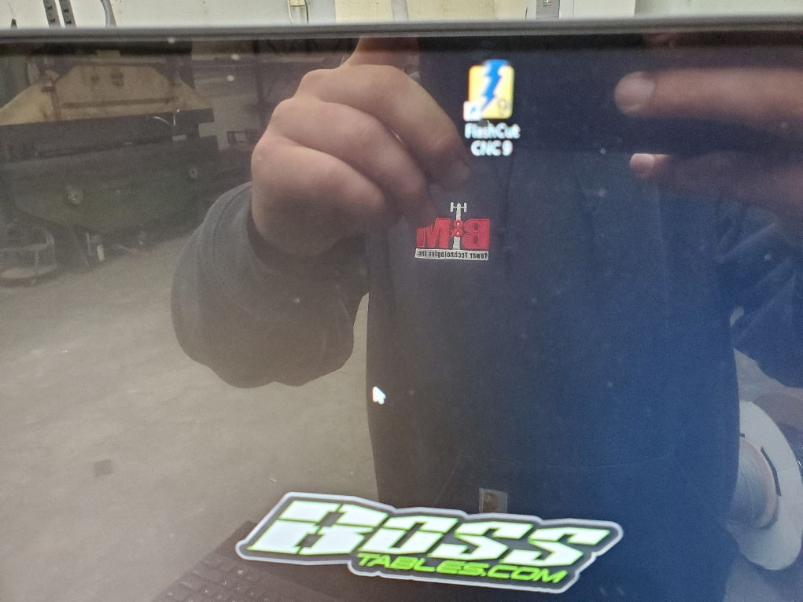
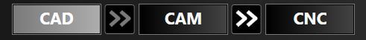
- Your machine will open in CAD Notice the Top If you want to jog your machine and home it click on CNC at the top of the screen.
- You can now jog your table around HOLDING Ctrl using the Arrow keys for left, right, up, and down. Use the PgUp and PgDn located above the arrow keys to travel the Z axis up and down. 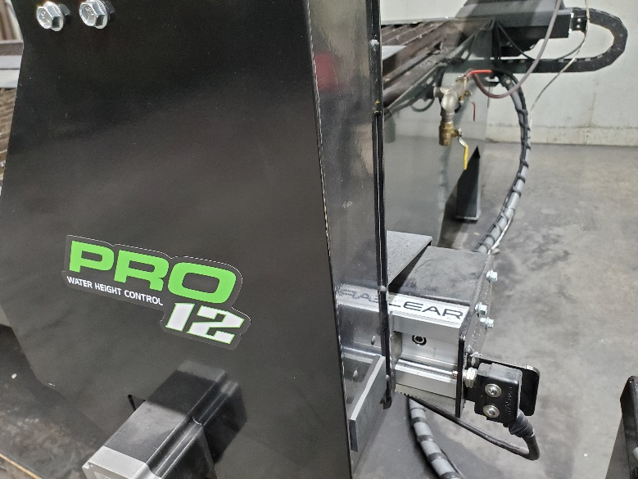
- You need to home the machine. To home the machine jog the table to the lower left side of the table. Do not ram the gantry into the stops. Stop 4 inches before the X and Y limit switch. Then select the Home X and wait till it touches the home switch. Then Select Home Y and wait for it to touch off the Home switch. Or select Home All and it will do both at the same time

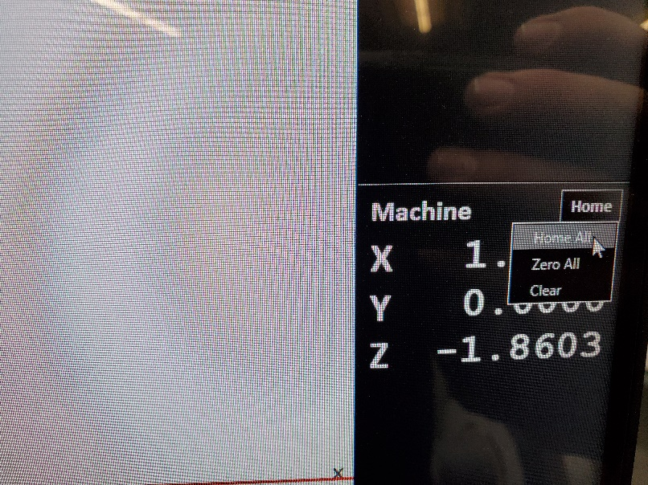
- The Z axis will be zeroed when the material loaded is to be cut. Zeroing the Z axis will let the machine know where the material is and the height of it.
- Granted that you followed the steps your machine is now set up and ready to accept Code to cut steel.
- This is very important for cut quality and operating your plasma.
- You can change the amperage of your power unit, this allows you to operate at a lower amperage and cut thinner material. More amps for thicker material.
- The tools are pre-loaded for Hypertherm in Flashcut. Pick appropriate tool in CAM and match the consumable tip size and amperage on power unit.
- Flashcut tool/ consumable tip/ setting on power unit must match.

Hypertherm Info

Powermax® machine-side reference guide
For mechanized applications with Powermax65/85/105 systems
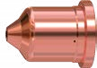
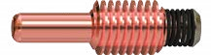
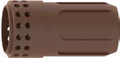
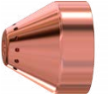
This Powermax machine-side reference guide is a supplement to your Operator Manual and includes examples of edge cut quality and consumable wear. Always refer to your Operator Manual for detailed safety and operating instructions.
Step 1
Select appropriate consumables and amperage
• Once you have determined the thickness of the
metal to be cut, use the chart to determine the
appropriate consumable type and amperage setting
for optimum cutting. The chart provides general
thickness ranges for cutting of mild steel. Refer
to your Operator Manual for detailed speed and
thickness measurements.
Step 2
Install consumables
Mechanized torch consumables
Decrease speed
Key
Increase speed
Optimum speed in inches per
minute for best cut quality
Consumable type and amperage
FineCut
A
40
FineCut
45
A
A
45
65
A
A
85
105
A
GA
26
24
GA
22
GA
20
GA
18
GA
16
GA
GA
14
12
GA
10
GA
/16"
3
1
/4"
/8"
3
/2"
1
/8"
5
/4"
3
/8"
7
"
1
1-1/8
"
1-1/4
"
"
1-1/2
ipm
325
120
ipm
70
ipm
30
ipm
ipm
24
21
ipm

• Use the chart on the right to install the appropriate consumables. Make sure the power is OFF before installing and changing consumables.
Mechanized consumables – engineered for the most productive mechanized cutting
Gouging consumables – designed for your toughest metal-removal jobs
CopperPlus™ consumables – an optional long-life electrode when cutting metal 1/2-inch thick or less FineCut® consumables – optimized for high-quality cuts on thin metal – for a clean edge and a narrow kerf Unshielded consumables – ideal for cutting in hard-to-reach areas and for the best arc visibility
Powermax105 – Use consumables up to 105 A
 |  | Shield/ deflector | Retaining cap | Nozzle | Electrode | Swirl ring
Mechanized | 105 A  85 A  65 A | 220993 | 220854 | 220990  220816  220819 | 220842 or  220777 | 220994
 |  | 220817 |  |  |  | 220857
 | 45 A |  |  | 220941
Mechanized, ohmic | 105 A ohmic  85 A ohmic  65 A ohmic | 220993 | 220953 | 220990  220816  220819 | 220842 | 220994
 |  | 220817 |  |  |  | 220857
 | 45 A ohmic |  |  | 220941
Unshielded | 105 A  85 A  65 A | 220955 | 220854 | 220990  220816  220819 | 220842 | 220994
 |  |  |  |  |  | 220857
 | 45 A |  |  | 220941
Gouging | 105 A  85 A  65 A | 220798 | 220854 | 220991 | 220842 | 220994
 |  |  |  | 220797 |  | 220857
FineCut | 45 A  45 A ohmic | 220955  220948 | 220854  220953 | 220930 | 220842 | 220947
Powermax85 – Use consumables up to 85 A Powermax65 – Use consumables up to 65 A

Non-continuous pilot arc Torch lock* Mode switch
Refer to your Operator Manual for instructions
*Not intended for Mechanized cutting applications
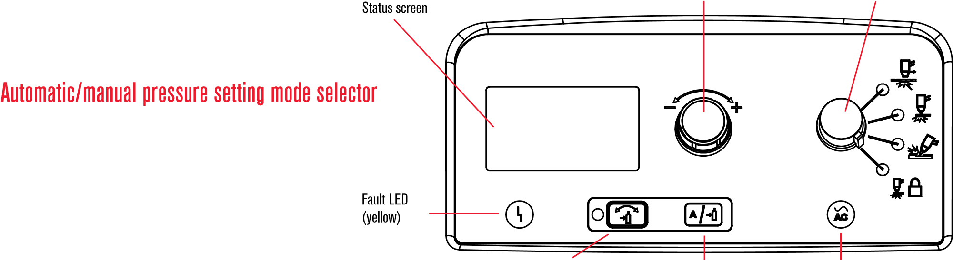

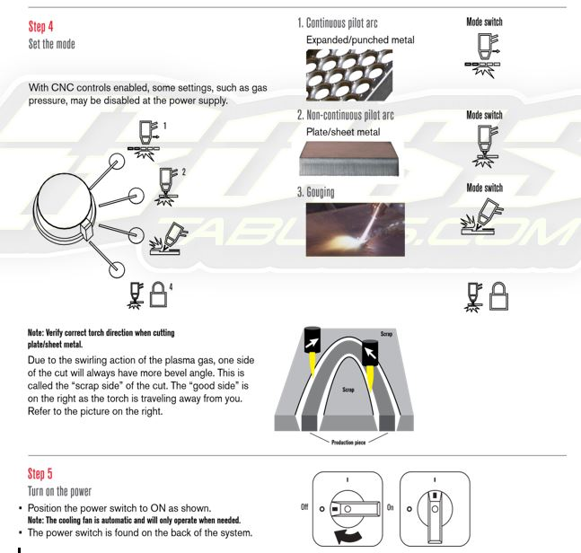

Set your amperage Adjustment knob Mode switch

The selector switches between automatic and manual mode. In automatic mode, the power supply automatically sets the gas pressure based upon the torch type and lead length and the adjustment knob sets only the amperage. In manual mode, the adjustment knob sets either the gas pressure or the amperage. This LED is illuminated in manual mode.
Note: Manual mode should be used by experienced users who need to optimize the gas setting (override the automatic gas setting) for a specific cutting application.
See Section 4 in your Operator Manual for adjusting your system in manual mode.

Check your status screen to ensure that there are no fault codes to troubleshoot
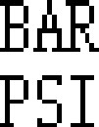
Torch started
Fault icon
Fault code
Torch is
cutting
Remote connected
Current setting
)
(
amps
Current
selection
cursor
Pressure
selection
cursor
Pressure
setting
Visual pressure setting

Automatic/manual pressure setting Current/gas Power ON LED mode selector selector (green
Warning/Fault codes
(refer to operator manual)
0-12 | Low input gas pressure: warning
0-13 | AC input unstable: warning
0-19 | Power board hardware protection
0-20 | Low gas pressure
0-21 | Gas flow lost while cutting
0-22 | No gas input
0-30 | Torch consumables stuck
0-32 | End of consumable life
0-40 | Over temperature
0-50 | Retaining cap off
0-51 | Start/trigger signal on at power up
0-52 | Torch not connected
0-60 | AC input voltage error
0-61 | AC input unstable: shutdown
0-98 | Internal communication failure
0-99 | System hardware fault – service required

See Section 4 in your Operator Manual for a full list of
Fault icons and Section 5 for basic troubleshooting.

 | 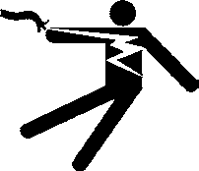 | DANGER  ELECTRIC SHOCK CAN KILL
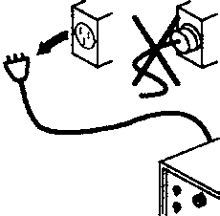
Disconnect the electrical power before you perform any maintenance. All work that requires removal of the power supply cover must be performed by a qualified technician.
Every use:
Inspect the consumables for proper installation and wear.
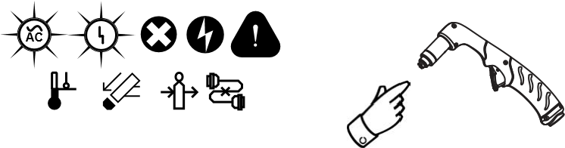
Check indicator lights and
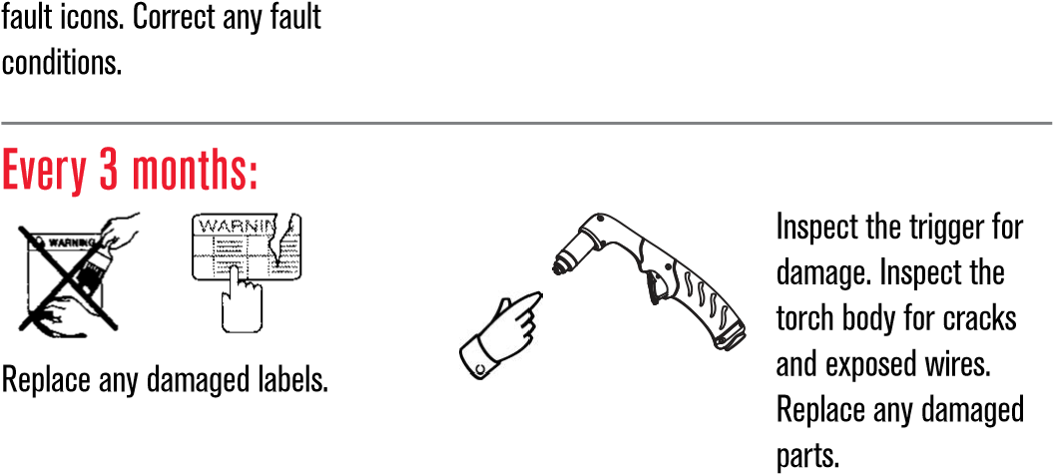
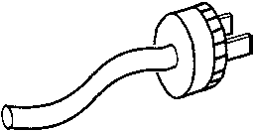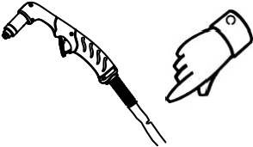
Inspect the power cord and plug. Replace if Inspect the torch lead. Replace damaged. if damaged.
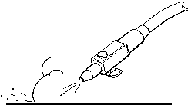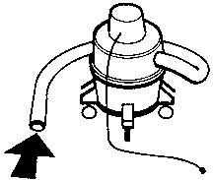
Clean the inside of
the power supply with
compressed air or a vacuum.
Every 6 months:
Or
Hypertherm, Powermax, and FineCut are trademarks of Hypertherm Inc. and may be registered in the United States and/or other countries.
Environmental stewardship is one of Hypertherm’s core values, and it is critical to our success and our customers’ success. We are striving to reduce the environmental impact of everything we do. For more information: www. hypertherm.com/environment.
™
©1/2018 Hypertherm Inc. Revision 2
894380

- Please reference your owner’s manual of your plasma for the proper tip tooling and cutting parts. VERY IMPORTANT TO HAVE THE CORRECT PARTS INSTALLED IN TIP TO MAINTAIN CUT QUALITY. Select the proper tip size which is also in correlation with you amperage. Example if you using a 65 amp tip you need you plasma cutter set to 65 amps. Failure to do so will result in consumable failure or poor cuts. 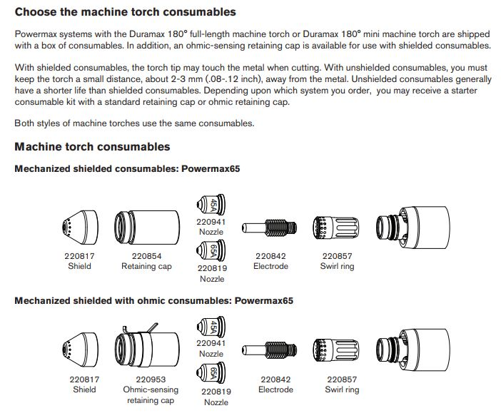
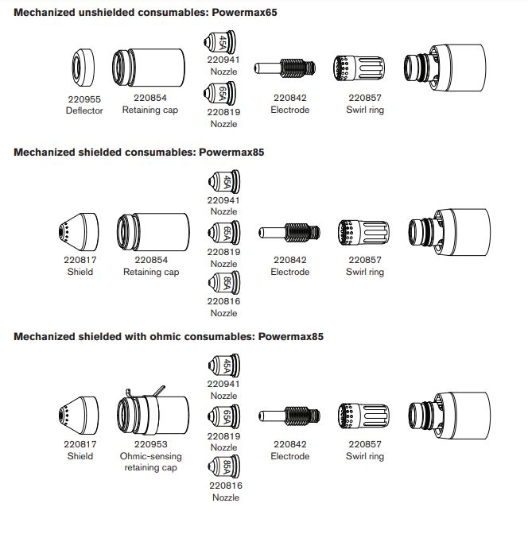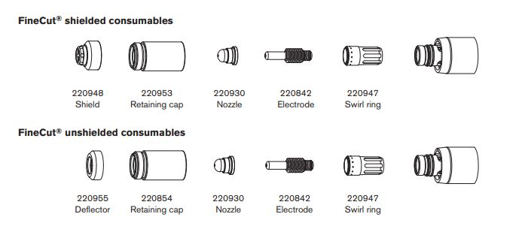
- Your feeds, speed, pierce delay, torch volts, ect will all be adjusted automatically. It can be reviewed by clicking on CAM Section located on the Top of the screen. Changes can be made accordingly if needed and the default tool set can always be uploaded again.

When Cam is open you have 2 options immediately. Blank sheet is New Cad/ Cam and the open folder is to open an Existing Cam Cam file.

You will be dealing with Cad/Cam files when your saving Jobs nests and parts ect. The are a file that has the tool path associated and every setting for the job saved.
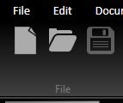

The other common file is DXF which is simply a vector image that allows you to create a tool path. Located on the right hand side of the screen. To bring in a simple DXF use DXF import.
In general DXF are more reliable than DWG. Cad Button will also open CAD/CAM Files.
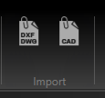
DXF Import
When you select DXF Import you need to hit the browse and find your files.
You can import more than one at a time and it will generate a toolpath for every part imported.
When the files are shown on screen and the progress bar is finished you need to hit the check mark at the bottom of the screen

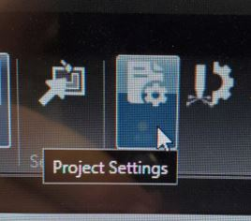 Clicking on this will open the box on the right side. This will change the project setting for the current job. If creating a new job, it will remember last job. You need to set the size of the job to nest your parts properly on your material.

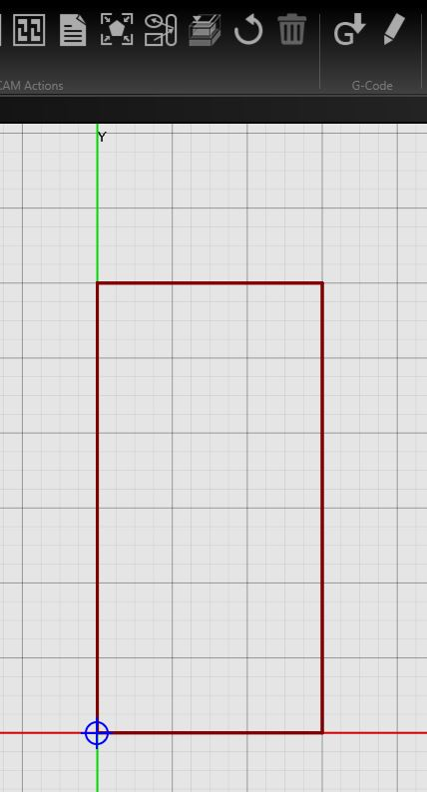
JOB Size
The Red Box is the Size of your Job, It will change depending on the info you change in the Workpiece box.

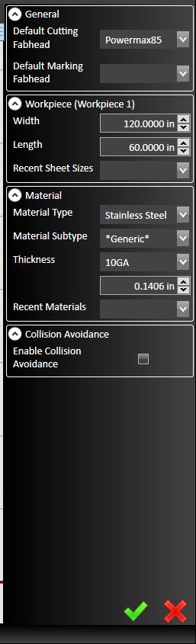
The fab head is not your tip size it your power unit size
Marking head is not used

Width of your work piece is determined by your mater size 48*96 ect.

Choose your material type an the thickness as it will change how the setting are implemented on the program.

Be sure to click the check mark at the bottom.

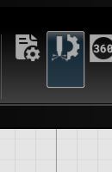 Clicking on the Plasma Setting will bring open another dialog box where you will adjust your cut settings.

This is especially important as if you have chosen the improper tool you will have bad results.

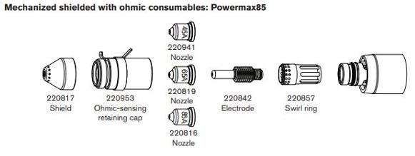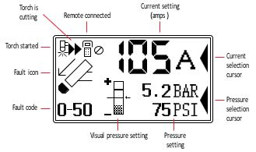
All NEED TO MATCH!
TIP
AMP on Machine
Setting in Controller
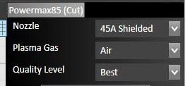
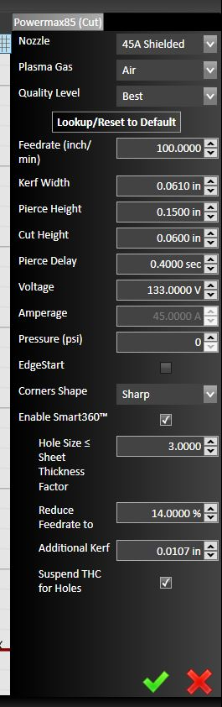
This is where you choose your tip size finecut, 45, 65, 85, Ect.
Gas is generally air
Best or production are the quality setting for the cut. Notice the feed change when adjusting.
You can change your feed rate manually and hit reset to default to reset.

Extend Pierce delay if cutting larger material and it does not pierce.
Voltage is you cut height, Higher the voltage the higher the cut.
PSI is changed manually on the machine.
Edge start is used when the material is too large to pierce.
You have the ability to change how the corner is cut.

Reduce federate for holes is especially useful to get better holes. 14% is low generally about 40-60 %
Suspend THC for holes should be checked if reducing federate for holes.
Path rules can always be left for holes.
Holes sets the feed to a set percentage (50%) or choice of user from the chosen tool path. EX. 45 amp 3/16 steel cuts at 63 IPM. When the holes rule is applied the cut in the hole will travel at 31.5 IPM on the inside of the hole. This will greatly improve the kerf (taper) quality of you holes.

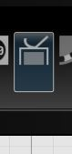 This Icon will allow you to adjust your lead in and lead out. Overcut and type of lead in.

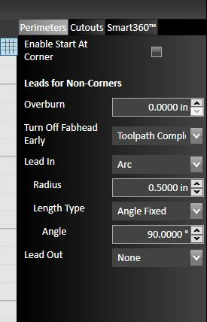
- Overcut is the distance past the start of the cut you would like to troch to travel while still cutting.

- Lead in and Lead out will allow you to pierce the material outside of the part with the selected distance. Lead In will pierce and travel toward feature as selected with choices of None, Arc, Tangent, and perpendicular. Arc is the most common choice. Lead out will do the same but finish the cut outside away from feature. Your lead out generally can be very small or not used at all.

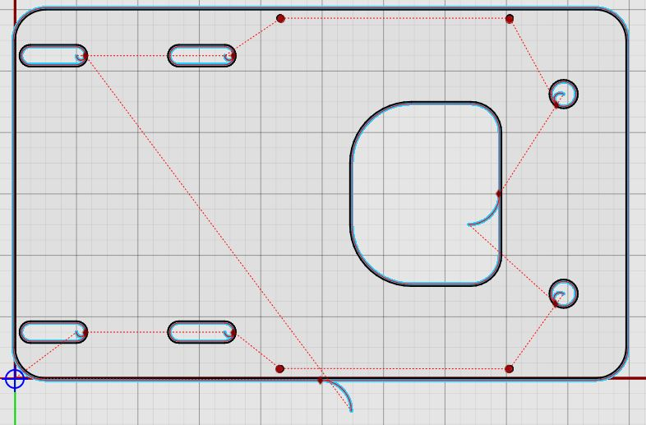

This is a tool path on a part imported as a DXF. You can see the lead in and how the circles are cut.

You can move the start points by dragging the red dots Notice how to turn on and off features in the drawing area. You can use the tool bar in upper right hand corner.
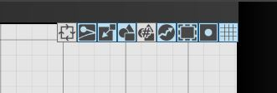
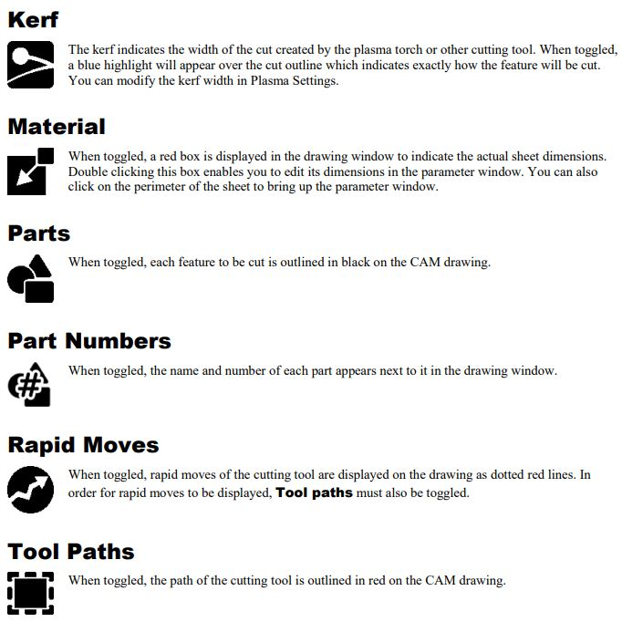

You Part is imported now you need to nest your parts. Manual nesting can be performed by clicking on the profile of the part and dragging the part while holding the left click on mouse. You can rotate by dragging corners of parts like so.
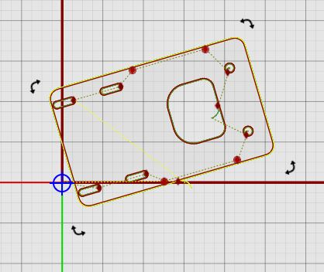

To Create Duplicates you can right click and hit copy or CTRL-C the Hit CTRL-V. They are the hot keys for cut and paste.

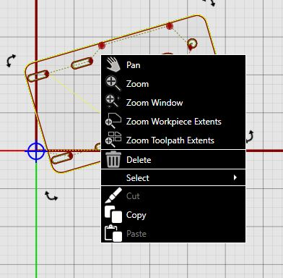

When you bring in another part it will automatically create a tool path like so.
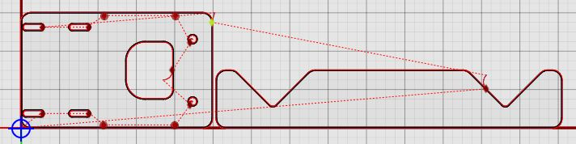

This is the auto nesting button, it will allow you to choose the number part you want.

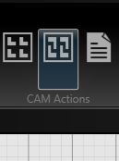 This is the auto nesting button. Click on it and you will open this window on the right hand side.

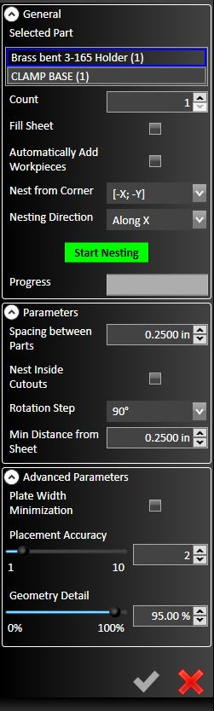
The parts are listed in the top area. In the (#) is the total number of parts desired.
The number of parts needed are entered in the count. Highlighted part count are adjust in the count box and will change the total in the (#)
Fill sheet will automatically add parts
Automatically add work pieces will add more sheets as needed for great quantities of parts.
Nesting Corner will group parts in the specified corner
Direction will choose the side to hug parts to.

Part spacing will adjust the gap between parts AND THE LEAD IN. MOVE IF NEEDED TO NEST TIGHTER

Rotation step will cange how many times it will rotate the parts at the determined angle. Smaller the step the more complicated parts will be nested but it will add time to the nesting process.
Distance from sheet will keep parts from the edge.
Placement accuracy 10 is the highest and will produce bester nest but add time to process.

Geometry detail if raised to 100 will give more concise part definition

When finished hit start nesting and review nest.
Hit Check Mark to Save

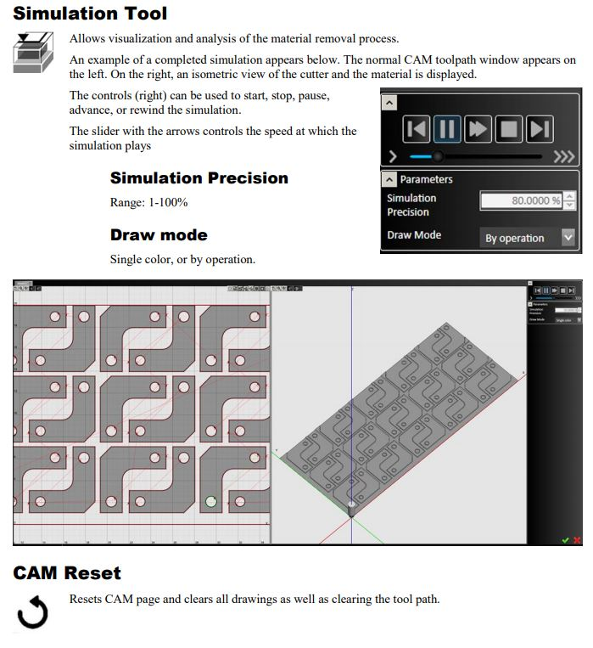

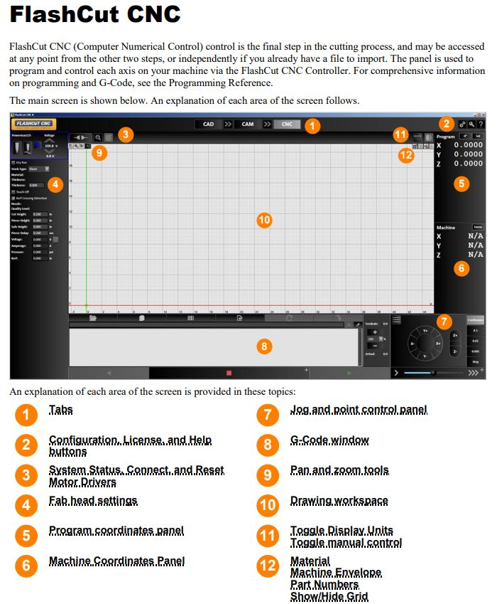

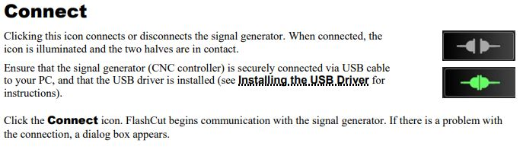

You need to connect your Controller To Operate

After Connecting HOLD Ctrl and use Arrow keys to jog around. Z Axis is ran by PgUp and PgDn.

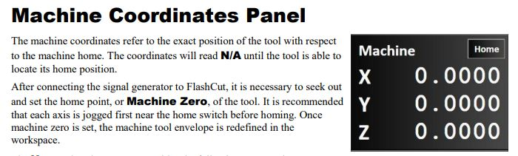

HOME YOUR MACHINE WHENEVER YOU TURN ON FLASHCUT OR CONNECT CONTROLLER

- You have homed your machine but your image is located in a random location. You will need zero you part location.
Home sets the machine parameters but it does not orientate the part on the machine. Once the machine is homed you will not be able to run the machine into the stops or run it off of the table.
Zero sets the part location located in the lower left of the screen oriented off of the torch. Travel your torch to any location and hit zero x and zero y to see the part move on the screen.
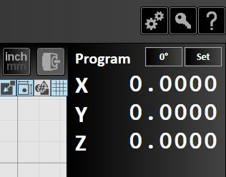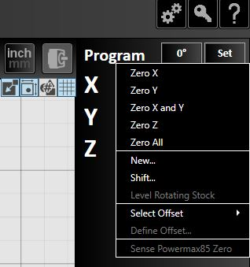
- Bring torch to the lower left of the steel to be cut and hit Zero X, Zero Y the part will be located off of the torch tip. If you nested your part 4 inches away for the lower left corner your part will be offset 4 inches from the tip.
- Your part is now nested on the steel to be cut. If desired depending on allotted room travel the torch around on the screen and verify that the part or parts are going to fit in allotted sheet. Used the arrow keys and the screen as a visual reference to see where the torch will travel.
- Shift Parts. If your going to cut outside of the allotted material by .25” then you can move the appropriate x and or y axis to a -.25 and rezero the part on the material. Shifting the parts nested by -.25. if you simply do not have enough room you will need to renest the parts on cam or resize the part.

- If you re-nest your parts you have essentially changed the g code needed to cut he appropriate job.
- Tip- you thought the steel was 16 gauge but there is 14 on the table you do not need to start over. Go Back change the operation to 14 on ALL the parts and click the arrows to move new code into controller
- Zero Z Axis. Everything looks good? You have told the machine where X and Y are oriented but you now need to zero the Z height. Travel down close to material and hit Zero Z
- Your part fits and your ready hit Run (Play button) in Lower center and you will be prompted to check settings. Hit ok and check settings. To start hit resume and your now cutting steel.
- The torch will travel to the initial pierce point and touch off the steel again. Finding the height of the steel and offsetting the pierce height. Torch will fire and drop down to cut height and continue on path wrote by flashcut.
- Do not stare at the arc as it will damage your eyes.

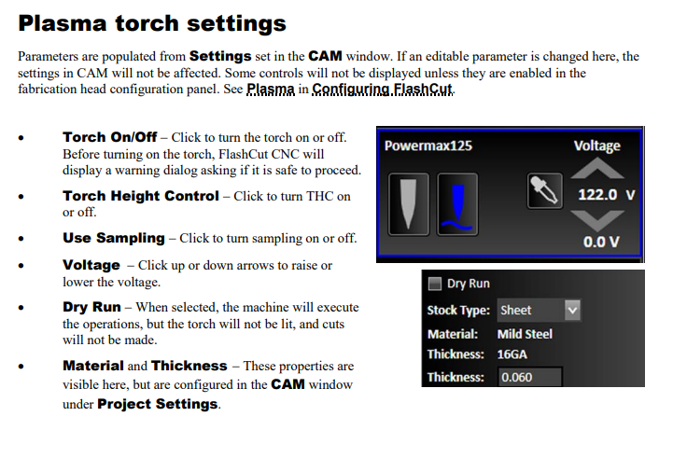
Generally you want the Torch Height control on and the Sampling on to maintain and adjust your torch cutting height. Turned on when illuminated blue.

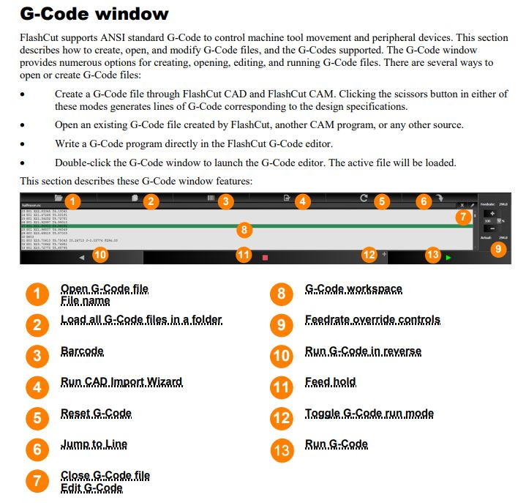

NOTICE # 12 When clicked this will appear Below

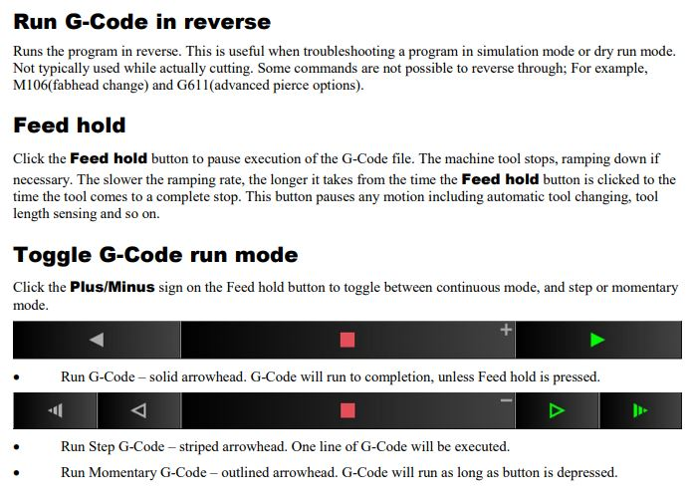

You can use this after you have had a collision. To reverse the G code and hit the “Play” or Start Button to restart the cut.

You have you tools paths created and your part nested (lower Left as that’s your 0-X 0-Y location) -Start with something simple please-

Operating the Cut Interface

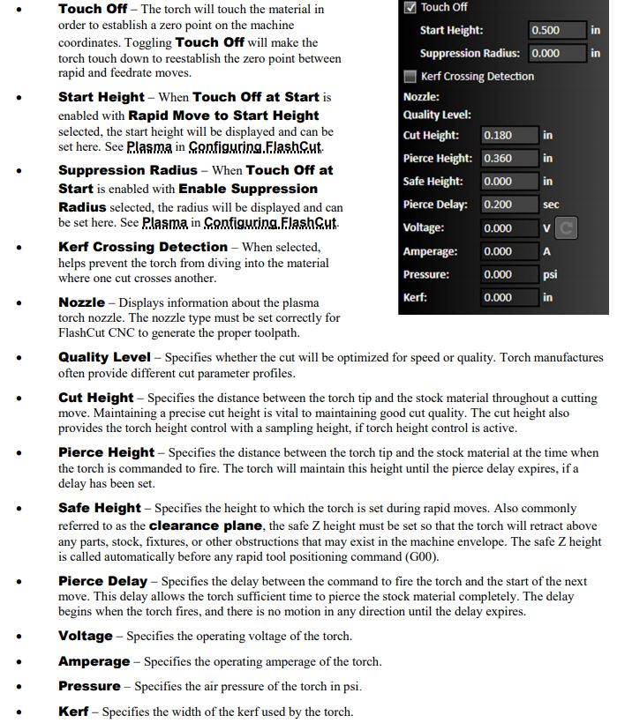

Notes/ Changes Made
________________________________________________________________________________________________________________________________________________________________________________________________________________________________________________________________________

